Nomination and Election of AFSCME Local 18
Vice President

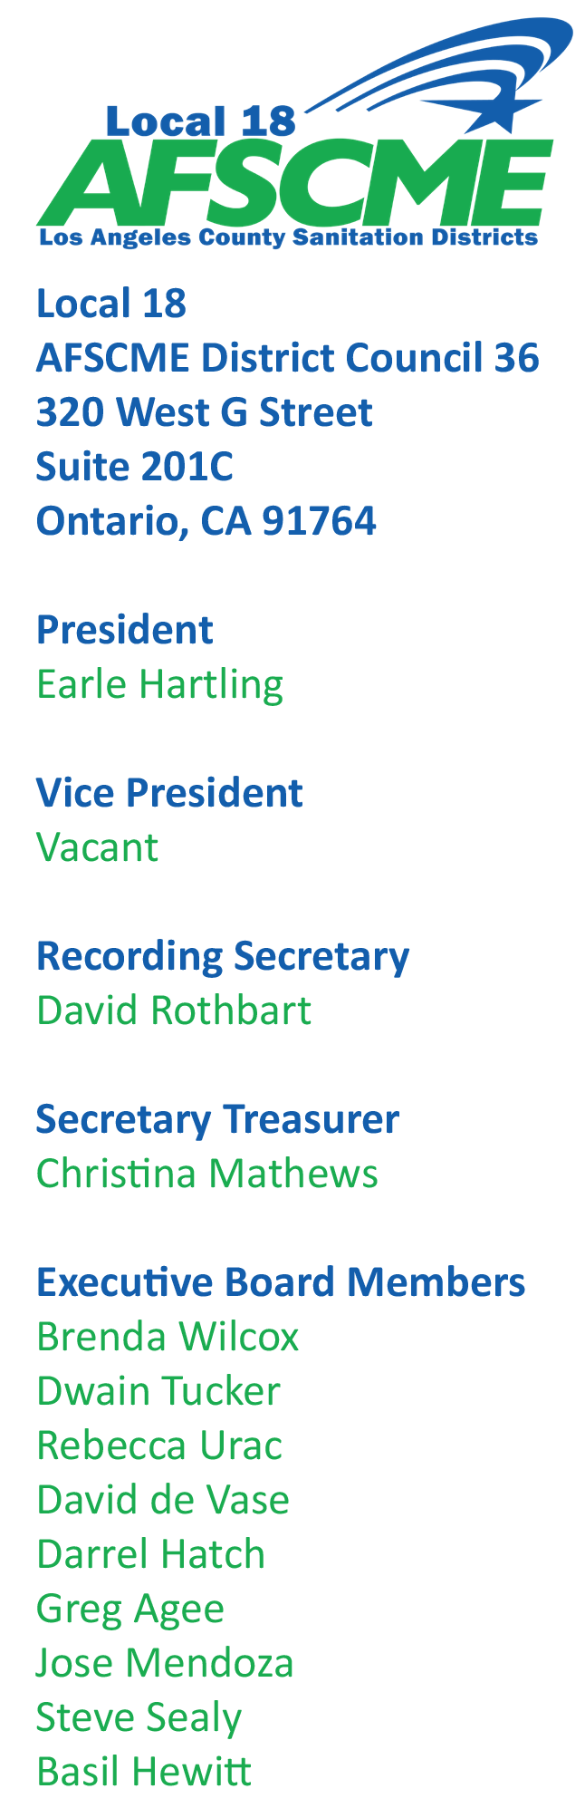
April 9, 2020

NOMINATIONS:

Because of restrictions with COVID-19, NOMINATIONS for office of Vice President for AFSCME Local 18 will be as follows:

DATE OPEN: April 30, 2020
CLOSE: May 1, 2020 @ 5pm

Nominations must be emailed to drothbart@gmail.com starting April 30, 2020.

QUALIFICATIONS:
Must be member in good standing.

ELECTION:

If there are multiple candidates nominated for office of VP an election will be conducted in accordance with AFSCME Election Code.

Ballots will be mailed out on May 5, 2020

DATE: May 5, 2020 Ballots mailed out
DUE: Must be returned by 5 P.M. Monday May 26, 2020

Questions- Luis Schmidt Luis@afscme36.org (213) 252-1396

