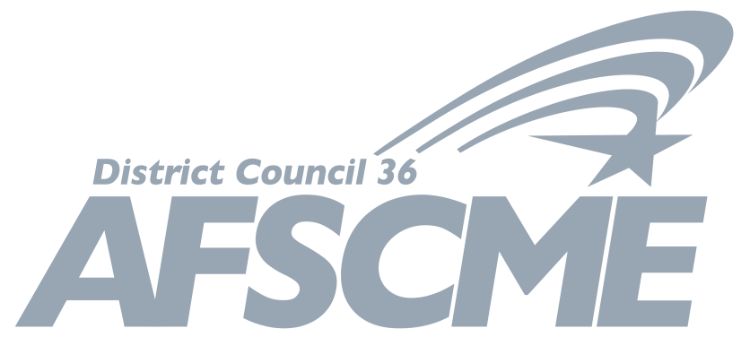
26th BIENNIAL CONVENTION OF AFSCME DISTRICT COUNCIL 36

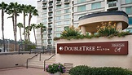

AFSCME District Council 36 is excited to announce our 26th Biennial Convention will be held at the Doubletree San Diego-Mission Valley, 7450 Hazard Center Drive, San Diego, California, 92108.
Dates are Friday, October 18 to Sunday, October 20, 2019.
Important business to be conducted at the Convention will include proposed amendments to the Council 36 Constitution and the nomination and election of Council’s Executive Board Members and Trustees.
Details about how to make hotel reservations and much more will be forthcoming. For now, please be sure to save the dates!
We hope to see you there!

